Control Award Content Sheet
Team #: 4322 Team Name: PHI Omega
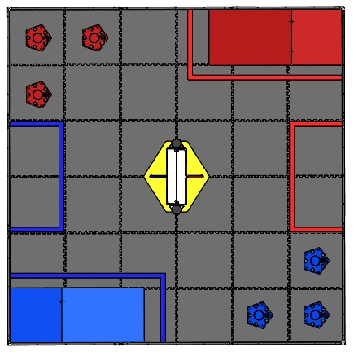
A

1

2
3
1
3
B

2

Autonomous:
A.
- Drive to the medium rolling goal. Use ultrasonic to align robot and latch on.
- Bring the tube to the parking zone, score the ball in the tube and release the hooks.
- Drive away and turn around to prepare for tele-op.
B.
- It checks the IR and if it is in position two or three it scores in the center goal and knocks down the kickstand.
- If the IR is in position one, it is considered too high a risk and we go grab the low rolling goal and bring it to the parking zone where we score the ball.
- Prepare for tele-op.

Driver Controlled:
- Stick Shaping to allow for precision driving and speed on one control stick.
- Multiple tasks to allow for running multiple things on the robot simultaneously
- Watchdog to watch for robot disconnect and stop motors to avoid burning them
- Optional drive type based on preference: single-stick vs. tank
- Light sensor to count balls entering robot to assist the driver

